

Quotation request
To undertake a ‘review of relevant literature’ to underpin MEI’s Theory of Change

Budget available for undertaking the work: Up to £10,000
Deadline for submitting four-page outline quotation:
1st August 2023
Deadline for completion of the work:
27th October 2023

The principal contact for this work is: Dr Stephen Lee (MEI Impact and Evaluation Lead), Mobile: 07447 444549, Email: stephen.lee@mei.org.uk

MEI’s address is: MEI Office, Monckton House, Epsom Centre, White Horse Business Park, Trowbridge, Wiltshire, BA14 0XG.

Introduction
MEI is an independent national charity (No 1058911) committed to improving maths education. It aims to make a real difference to people’s lives by improving the quality of maths education and learning. Additional background on MEI can be seen in Annex 1.

MEI has a Theory of Change that attempts to summarise the reasoning behind what it does and what it aims to achieve as a result. Information on MEI’s Theory of Change can be seen in Annex 2.

MEI’s Theory of Change is not fixed; it is adapted over time. Therefore:
MEI is seeking to commission an individual or organisation to undertake a ‘review of relevant literature’ to underpin aspects of its Theory of Change.
The primary audience for the work will be MEI’s Senior Leadership Team and Trustees. It will be valuable for MEI to reflect upon its strategic goals/objectives. It will also support MEI when making future funding applications.

The Requirement

Task A | Convene an initial meeting with MEI to:  - Establish a common understanding of MEI’s Theory of Change.  - Propose and agree with MEI a mechanism for cataloguing relevant literature, key points, and their links.  - Agree a plan for undertaking tasks B and C.
Task B | From MEI’s Theory of Change (see Annex 2), conduct a review of relevant literature for items associated with:  - Change Mechanism 2 (teacher professional development)  - Change Mechanism 3 (teacher use of resources)  Change Mechanisms 2 and 3 feed into Outcome 2 – ‘The quality of maths teaching is improved, and learning is enriched’.  Evidence from the relevant literature should be applicable to England’s education system and its schools/colleges.
Task C | Produce useable and relevant outputs from the review:  - A short update document by 8th September 2023. This should give a brief summary of progress and include some examples of relevant literature.  - Details of the relevant literature, key points and their links curated in a way as agreed in Task A.  - An overarching final report from the review, by 27th October 2023. As part of the quotation process the proposer should indicate what they consider would be a suitable style for the final report, taking into account the overall budget and time available.

2 Quotation Process
Quotations from organisations of all sizes are welcome, including individual researchers.
Your response to this quotation request should be presented in a single Word or PDF document that has two parts:
PART 1 – Background Information (No more than one A4 page in length)
- Please provide a high-level overview of you/your organisation, its services and its capabilities.
[With a very short page limit it is permissible for you to provide links, e.g., to specific pages on a website. However, this should not detract from the overall readability.]

PART 2 – Proposal (No more than three A4 pages in length)
- Please provide your response to The Requirement described as Tasks A, B and
C. This should include:
  - An outline of your proposed approach to the tasks, including a timeline for proposed activity for August to October 2023. Note. You should be explicit in the proposal how you would catalogue the relevant literature, and what format your final report would take.
  - Detail of input or support that is required from MEI.
  - A summary of costs: total budget including any VAT costs.
  - Two customer references with contact numbers and e-mail addresses that MEI could follow up on (contact would only take place with your prior permission at the appropriate stage of the quotation process).

Budget, timeline and submission

The budget for this work is of value of up to £10,000 (inclusive of VAT).

The deadline for submitting an outline quotation for the work is 1st August 2023.

The outline quotation should be emailed to both Stephen Lee (Stephen.lee@mei.org.uk) and Rachel Ball (rachel.ball@mei.org.uk) by noon on 1st August 2023.

If you wish to make a hard copy submission, then please notify us of this intention. A hard copy is not required, however if you wish to use this method then please send for the attention of Rachel Ball at the address on page 2. The outside of the package should be marked with the reference “MEI Theory of Change response”.
The deadline for completion of the work is 27th October 2023.

After the submission deadline of 1st August 2023, quotations will be reviewed, and a preferred supplier identified by Friday 4th August. Work should start asap thereafter and the initial meeting between MEI and the supplier should ideally take place by 11th August.

The selection will be made based on capability to deliver the required work against the agreed timescale and within budget, as assessed through the quality and suitability of the proposal submitted.

Annex 1 – About MEI

Mathematics in Education and Industry (MEI)

MEI is an independent national charity (No 1058911) committed to improving maths education. It aims to make a real difference to people’s lives by improving the quality of maths education and learning.

MEI supports the teaching, learning and assessment of maths by developing curriculum specifications and schemes of assessment; providing professional development for teachers; and publishing teaching and learning resources.

MEI offers teachers of all maths GCSE and A level specifications a range of continuing professional development courses, provides specialist tuition for students and works to enhance mathematical skills in the workplace. MEI also pioneers the development of innovative mathematics curricula and resources to support teaching and learning, including extensive online materials.

MEI’s work in the development and leadership of the DfE-funded Advanced Mathematics Support Programme (AMSP) and National Centre for Excellence in the Teaching of Mathematics (NCETM) enables MEI to have a sustainable national impact.

Annex 2 – MEI’s Theory of Change
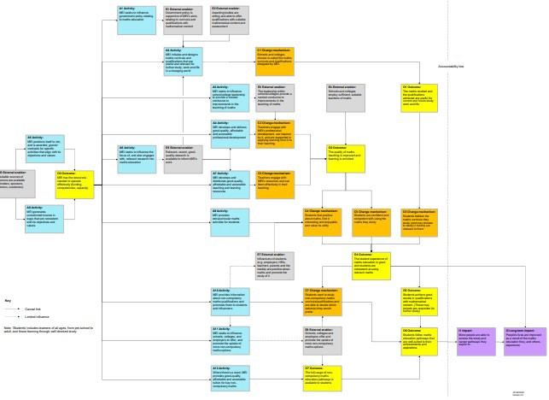
Note. The Theory of Change is deliberately blurred here. The purpose is to show where relevant items to be reviewed in this proposal, listed below, are positioned.

Items of particular focus for the review of relevant literature:

Change mechanism 2:
Teachers engage with professional development, are inspired by it, and are supported in applying learning from it to their teaching. |  |  | Outcome 2:
 |  |  | The quality of maths teaching is improved, and learning is enriched.
Change mechanism 3:
Teachers engage with resources and use them effectively in their teaching.

